[](https://www.insidesherpa.com/dashboard)

* [View open jobs at KPMG →](https://www.insidesherpa.com/open-jobs/NbfckfeuMiyuCfQc7/m7W4GMqeT3bh9Nb2c/KPMG)
* Allow KPMG to contact me

[](https://www.insidesherpa.com/virtual-internships/m7W4GMqeT3bh9Nb2c)

[Homepage](https://www.insidesherpa.com/virtual-internships/theme/m7W4GMqeT3bh9Nb2c/KPMG-Data-Analytics-Virtual-Internship)   >   [Module Overview Page](https://www.insidesherpa.com/virtual-internships/m7W4GMqeT3bh9Nb2c)  >   [Data Quality Assessment](https://www.insidesherpa.com/modules/m7W4GMqeT3bh9Nb2c/S3uFvbDL49EA43ukg)

Task 1

**Data Quality Assessment**

Assessment of data quality and completeness in preparation for analysis

[[](https://www.insidesherpa.com/modules/m7W4GMqeT3bh9Nb2c/S3uFvbDL49EA43ukg#step1)](https://www.insidesherpa.com/modules/m7W4GMqeT3bh9Nb2c/S3uFvbDL49EA43ukg" \l "step1)

[Watch video instructions](https://www.insidesherpa.com/modules/m7W4GMqeT3bh9Nb2c/S3uFvbDL49EA43ukg" \l "step1)

[[](https://www.insidesherpa.com/modules/m7W4GMqeT3bh9Nb2c/S3uFvbDL49EA43ukg#step2)](https://www.insidesherpa.com/modules/m7W4GMqeT3bh9Nb2c/S3uFvbDL49EA43ukg" \l "step2)

[Get background info and context](https://www.insidesherpa.com/modules/m7W4GMqeT3bh9Nb2c/S3uFvbDL49EA43ukg" \l "step2)

[[](https://www.insidesherpa.com/modules/m7W4GMqeT3bh9Nb2c/S3uFvbDL49EA43ukg#step3)](https://www.insidesherpa.com/modules/m7W4GMqeT3bh9Nb2c/S3uFvbDL49EA43ukg" \l "step3)

[Get details for your task](https://www.insidesherpa.com/modules/m7W4GMqeT3bh9Nb2c/S3uFvbDL49EA43ukg" \l "step3)

[[](https://www.insidesherpa.com/modules/m7W4GMqeT3bh9Nb2c/S3uFvbDL49EA43ukg#step4)](https://www.insidesherpa.com/modules/m7W4GMqeT3bh9Nb2c/S3uFvbDL49EA43ukg" \l "step4)

[View resources to help you learn](https://www.insidesherpa.com/modules/m7W4GMqeT3bh9Nb2c/S3uFvbDL49EA43ukg" \l "step4)

[[](https://www.insidesherpa.com/modules/m7W4GMqeT3bh9Nb2c/S3uFvbDL49EA43ukg#step5)](https://www.insidesherpa.com/modules/m7W4GMqeT3bh9Nb2c/S3uFvbDL49EA43ukg" \l "step5)

[Submit your work on this page](https://www.insidesherpa.com/modules/m7W4GMqeT3bh9Nb2c/S3uFvbDL49EA43ukg" \l "step5)

[[](https://www.insidesherpa.com/modules/m7W4GMqeT3bh9Nb2c/S3uFvbDL49EA43ukg#step6)](https://www.insidesherpa.com/modules/m7W4GMqeT3bh9Nb2c/S3uFvbDL49EA43ukg" \l "step6)

[Unlock the model work](https://www.insidesherpa.com/modules/m7W4GMqeT3bh9Nb2c/S3uFvbDL49EA43ukg" \l "step6)

**1**

**Get your instructions from your supervisor**

Watch this video and hear about your task.

Optional: Employment Preferences

**What kind of employment opportunities are you looking for?**

* Pre-internship
* Internships / Vacation schemes
* Full time

🌏  Update working rights  →

📃  Upload your Resume  →

This helps companies on InsideSherpa reach out to you for the right roles.

**2**

**Here is the background information on your task**

Sprocket Central Pty Ltd , a medium size bikes & cycling accessories organisation, has approached Tony Smith (Partner) in KPMG’s Lighthouse & Innovation Team. Sprocket Central Pty Ltd  is keen to learn more about KPMG’s expertise in its Analytics, Information & Modelling team. 

Smith discusses KPMG’s expertise in this space (you can read more [**here**](https://home.kpmg/au/en/home/services/advisory/management-consulting/digital/data-analytics-modelling.html)). In particular, he speaks about how the team can effectively analyse the datasets to help Sprocket Central Pty Ltd grow its business.

Primarily, Sprocket Central Pty Ltd needs help with its customer and transactions data. The organisation has a large dataset relating to its customers, but their team is unsure how to effectively analyse it to help optimise its marketing strategy. 

However, in order to support the analysis, you speak to the Associate Director for some ideas and she advised that “*the importance of optimising the quality of customer datasets cannot be underestimated. The better the quality of the dataset, the better chance you will be able to use it drive company growth*.”

The client provided KPMG with 3 datasets:

* Customer Demographic
* Customer Addresses
* Transactions data in the past 3 months

You decide to start the preliminary data exploration and identify ways to improve the quality of Sprocket Central Pty Ltd’s data.

**3**

**Here is your task**

You arrive at your desk after the initial client meeting. You have a voicemail on your phone which contains the following instructions.

[Voicemail transcript below]

“*Hi there – Welcome again to the team! The client has asked our team to assess the quality of their data; as well as make recommendations on ways to clean the underlying data and mitigate these issues.  Can you please take a look at the datasets we’ve received and draft an email to them identifying the data quality issues and how this may impact our analysis going forward?*

*I will send through an example of a typical data quality framework that can be used as a guide. Remember to consider the join keys between the tables too. Thanks again for your help*.”

[Read email below]

*Hi there,*

*As per voicemail, please find the 3 datasets attached from Sprocket Central Pty Ltd:*

* *Customer Demographic*
* *Customer Addresses*
* *Transaction data in the past three months*

*Can you please review the data quality to ensure that it is ready for our analysis in phase two. Remember to take note of any assumptions or issues we need to go back to the client on. As well as recommendations going forward to mitigate current data quality concerns.*

*I’ve also attached a data quality framework as a guideline. Let me know if you have any questions.*

*Thanks for your help.*

*Kind Regards  
Your Manager*

**Here is your task:**

**Draft an email** to the client identifying the data quality issues and strategies to mitigate these issues. Refer to ‘Data Quality Framework Table’ and resources below for criteria and dimensions which you should consider.

**Items Required to do this module:**

[[](https://s3-ap-southeast-2.amazonaws.com/insidesherpa-assets/vinternship_modules/kpmg_data_analytics/KPMG_VI_New_raw_data_update_final.xlsx)](https://s3-ap-southeast-2.amazonaws.com/insidesherpa-assets/vinternship_modules/kpmg_data_analytics/KPMG_VI_New_raw_data_update_final.xlsx" \t "_blank)

**[Required File: The dataset from Sprocket Central](https://s3-ap-southeast-2.amazonaws.com/insidesherpa-assets/vinternship_modules/kpmg_data_analytics/KPMG_VI_New_raw_data_update_final.xlsx" \t "_blank)**

[This is the dataset to evaluate for data quality. Read the instructions on the title sheet. There are multiple sheets.](https://s3-ap-southeast-2.amazonaws.com/insidesherpa-assets/vinternship_modules/kpmg_data_analytics/KPMG_VI_New_raw_data_update_final.xlsx" \t "_blank)

[KPMG\_Virtual\_internship\_dataset\_insidesherpa.xlsx](https://s3-ap-southeast-2.amazonaws.com/insidesherpa-assets/vinternship_modules/kpmg_data_analytics/KPMG_VI_New_raw_data_update_final.xlsx" \t "_blank)

**[Click to download file →](https://s3-ap-southeast-2.amazonaws.com/insidesherpa-assets/vinternship_modules/kpmg_data_analytics/KPMG_VI_New_raw_data_update_final.xlsx" \t "_blank)**

[File copyright KPMG. For use for the Virtual Internship Only.](https://s3-ap-southeast-2.amazonaws.com/insidesherpa-assets/vinternship_modules/kpmg_data_analytics/KPMG_VI_New_raw_data_update_final.xlsx" \t "_blank)

You may use programs like Excel, [Google Sheets,](https://www.google.com.au/sheets/about/) [Tableau,](https://www.tableau.com/) P[ower BI to start. Feel free to use Python, R Programming Language, MatLab and other data analytics tools that you know of.](https://powerbi.microsoft.com/en-us/)

**4**

**Resources to help you with the task**

**Data Quality Framework Table**Below is a list of the Data Quality dimensions our team may use to evaluate a dataset. Some of these terms are common to the whole industry, so you may find more information and clarity on these terms by searching online.

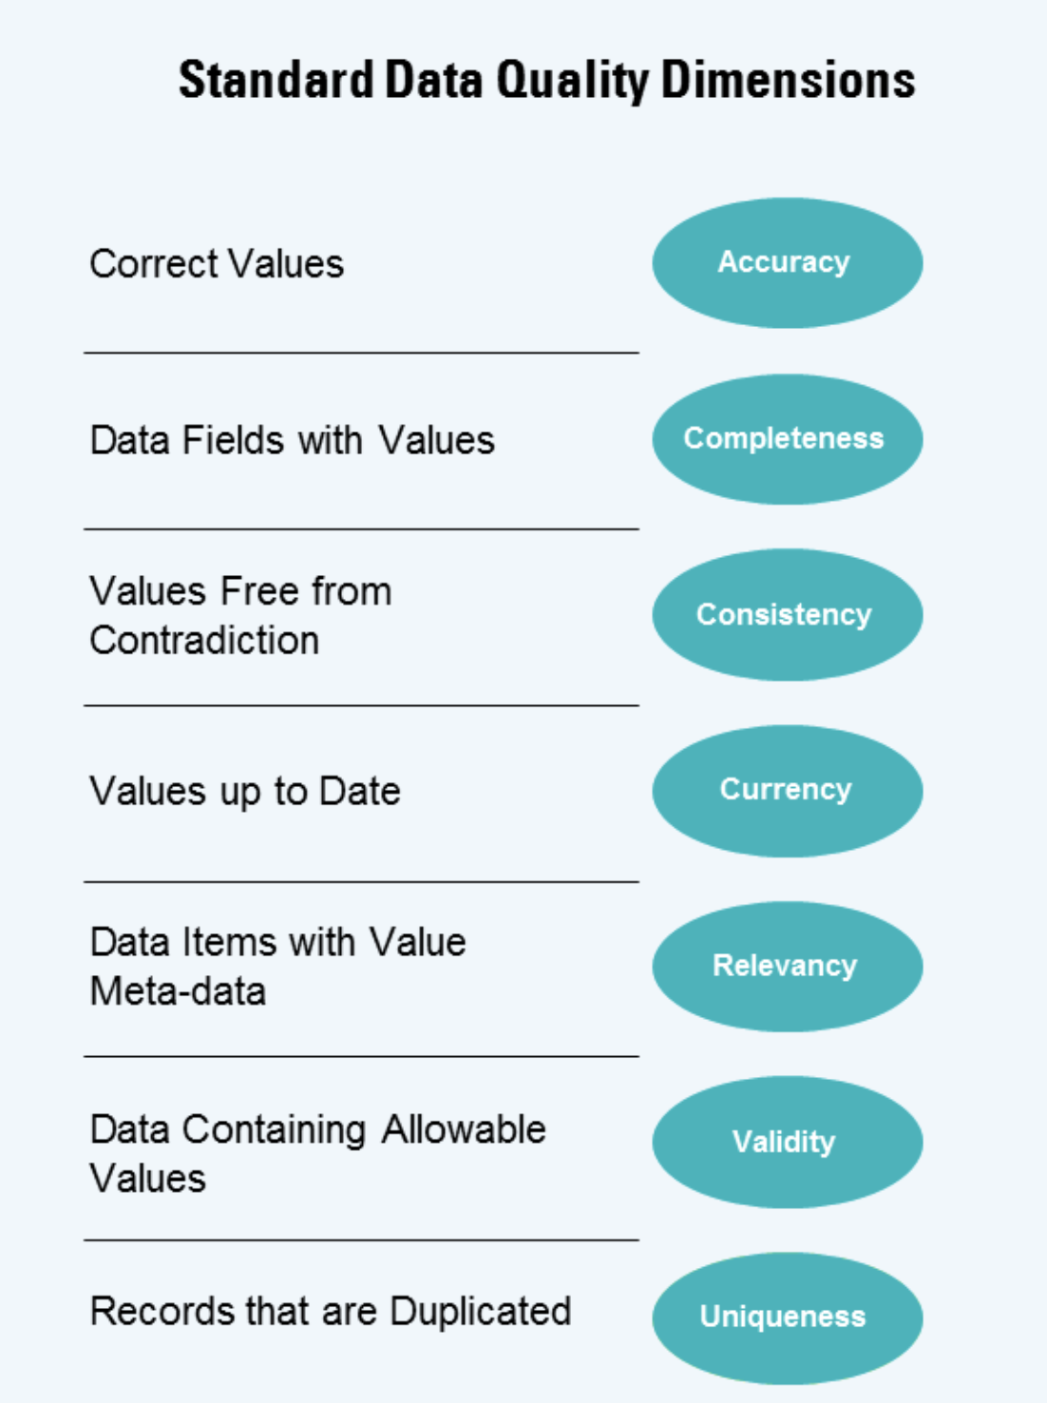

**5**

**Submit your work**

You may only credit this task to your CV if you make a genuine attempt at the work. You may resubmit work, iterate upon and reattempt work as many times as you want.

**Practice or learning attempt:**

 toggle this switch to flag this was a practice attempt to KPMG

Top of Form

Drop files here or click to upload.(You can resubmit your work as many times as you wish)

Bottom of Form

**6**

**Unlock the model work**

Download an example of work done at KPMG in this topic. Submit an attempt at work first before this unlocks.

This model work was created by a Senior Consultant in the Data Analytics Team. The model work replicates real work done by the team at KPMG. Submit an attempt to unlock the expert sample.



[Go to the Module Overview Page](https://www.insidesherpa.com/virtual-internships/m7W4GMqeT3bh9Nb2c)

[Next Task →](https://www.insidesherpa.com/modules/m7W4GMqeT3bh9Nb2c/PH6AYWBqqJvSzDBbd)

© 2018 KPMG, an Australian partnership and a member firm of the KPMG network of independent member firms affiliated with KPMG International Cooperative (“KPMG International”), a Swiss entity. All rights reserved.

[](https://www.insidesherpa.com/)

[Privacy Policy](https://www.insidesherpa.com/privacy) [Terms of Use](https://www.insidesherpa.com/terms) © Copyright 2020